# POC on python scripting for Behave BDD Playwright automation framework

Submitted by: Automation QA team ( Impressico )

Project Structure:

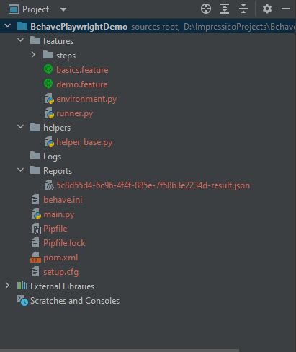

Feature file:

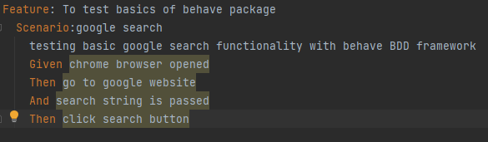

Environment file:

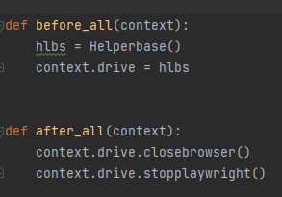

Helper file:

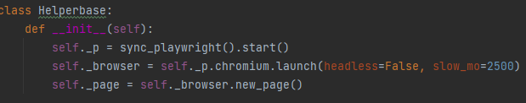

Python Playwright Code Snippet(Step\_definition):

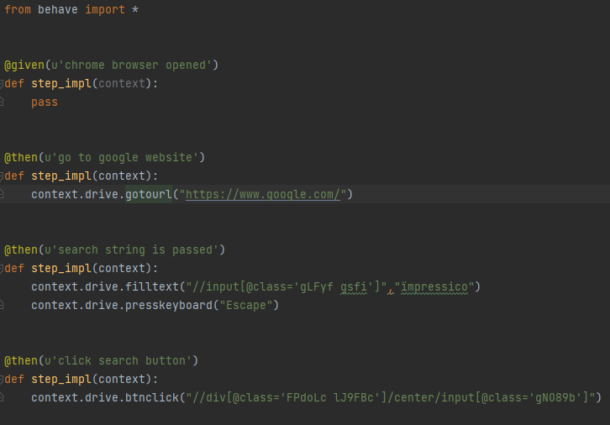

Results:

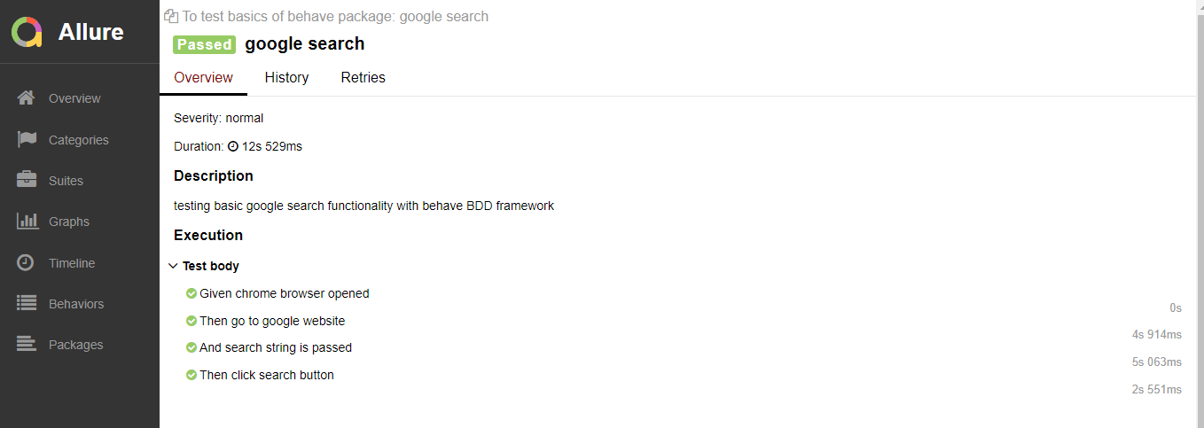

Scripting language:

Python

Command line arguments:

* behave -f allure\_behave.formatter:AllureFormatter -o Reports ./features/basics.feature
* allure serve <Reports-folder>

Tools and Plugin details:

* Maven-exec plugin
* pip
* behave - framework
* allure- reports
* Pycharm IDE

References**:**

<https://playwright.dev/python/docs/intro>

<https://behave.readthedocs.io/en/stable/index.html>

[https://docs.qameta.io/allure/#\_get\_started](https://docs.qameta.io/allure/" \l "_get_started)